ASSIGNMENT-1

1. 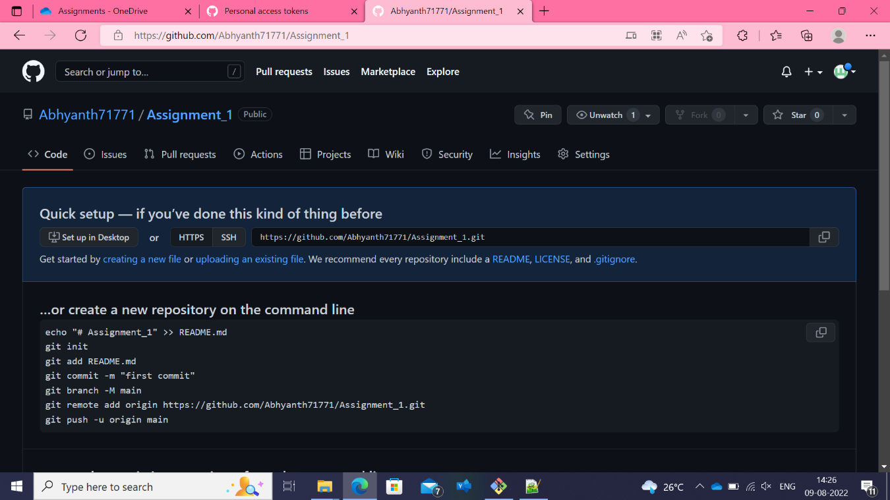

2. git clone [Abhyanth71771/Assignment_1: Assignment_1 Day 1 of git training (github.com)](https://github.com/Abhyanth71771/Assignment_1)

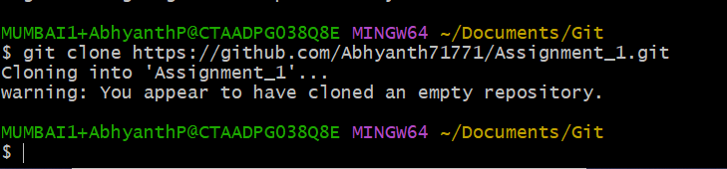

3.

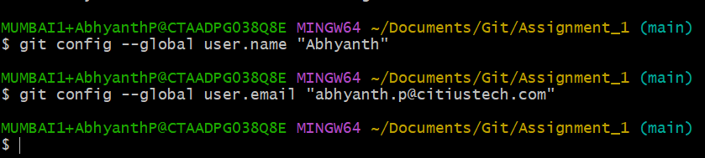

4.

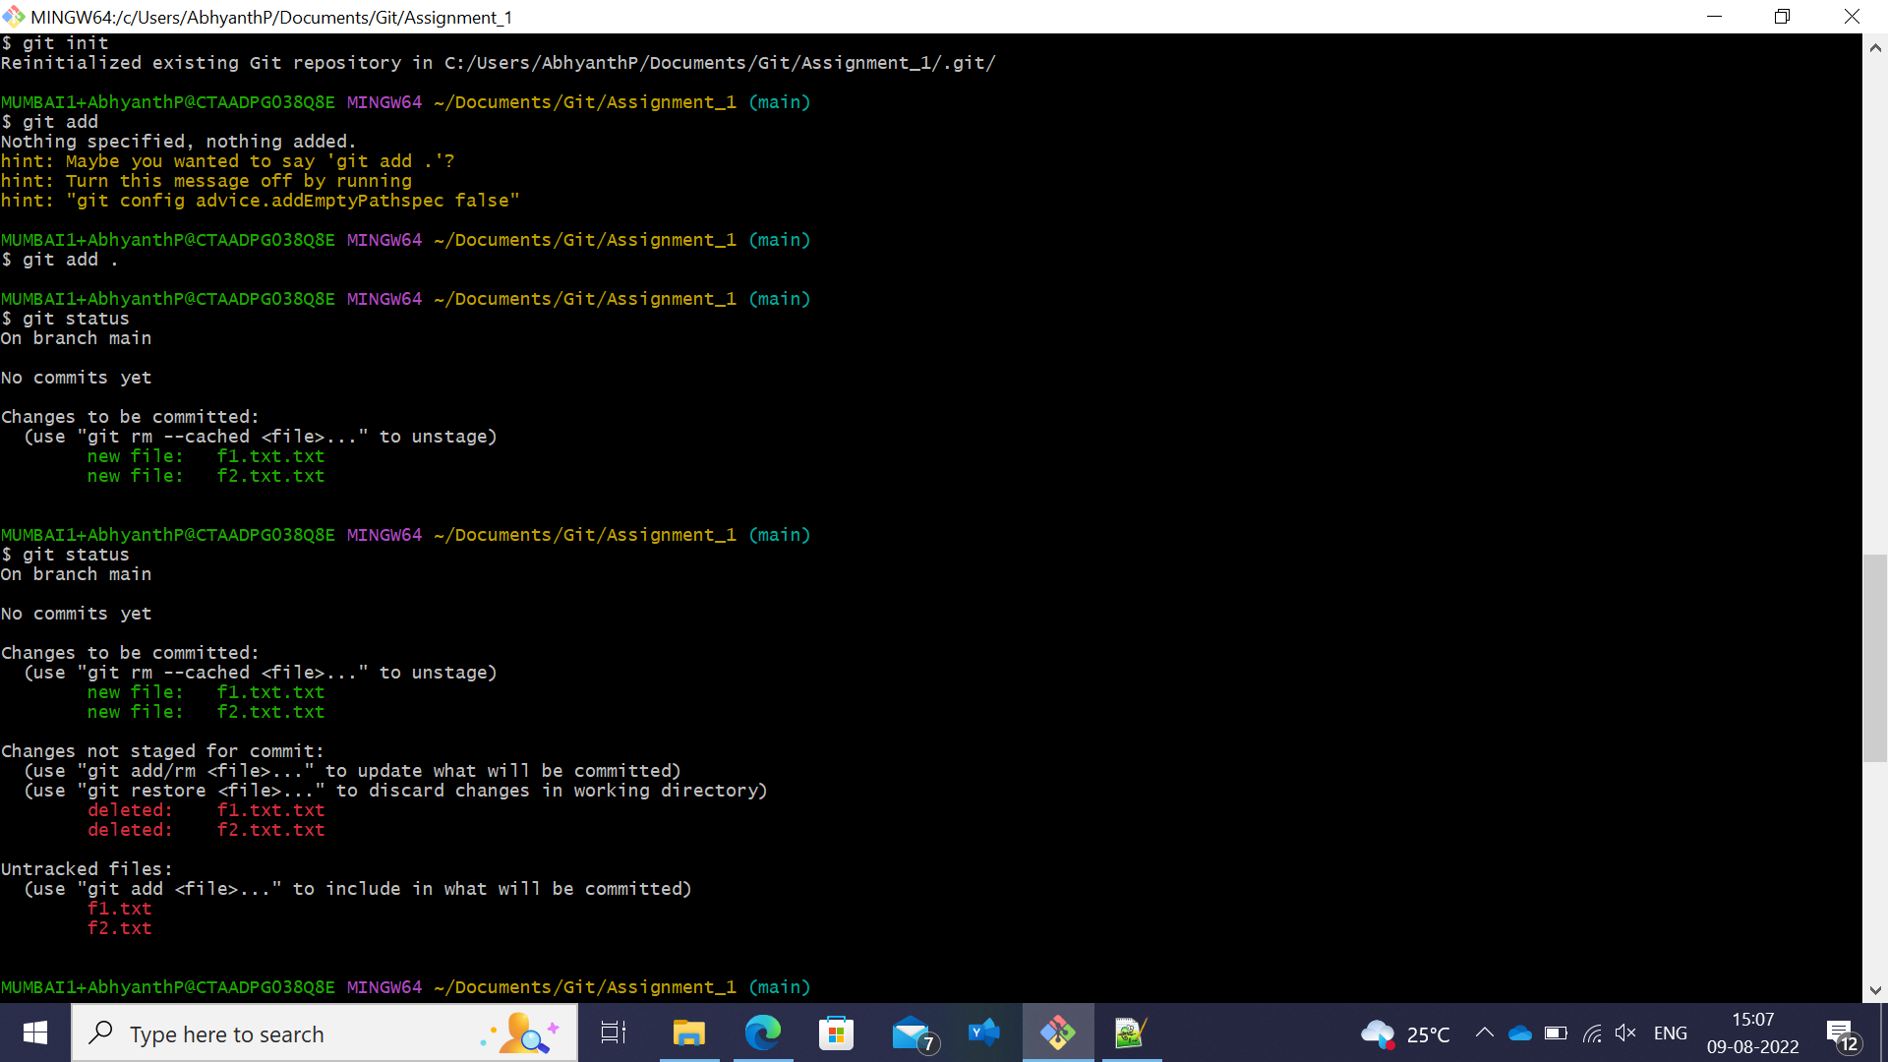

5. 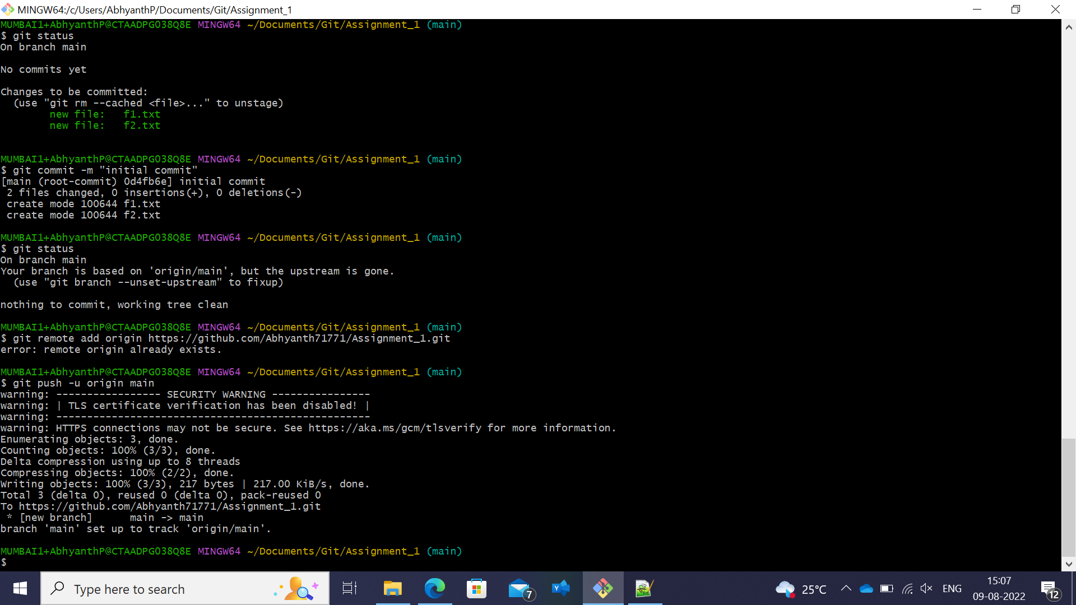

6. 

7. 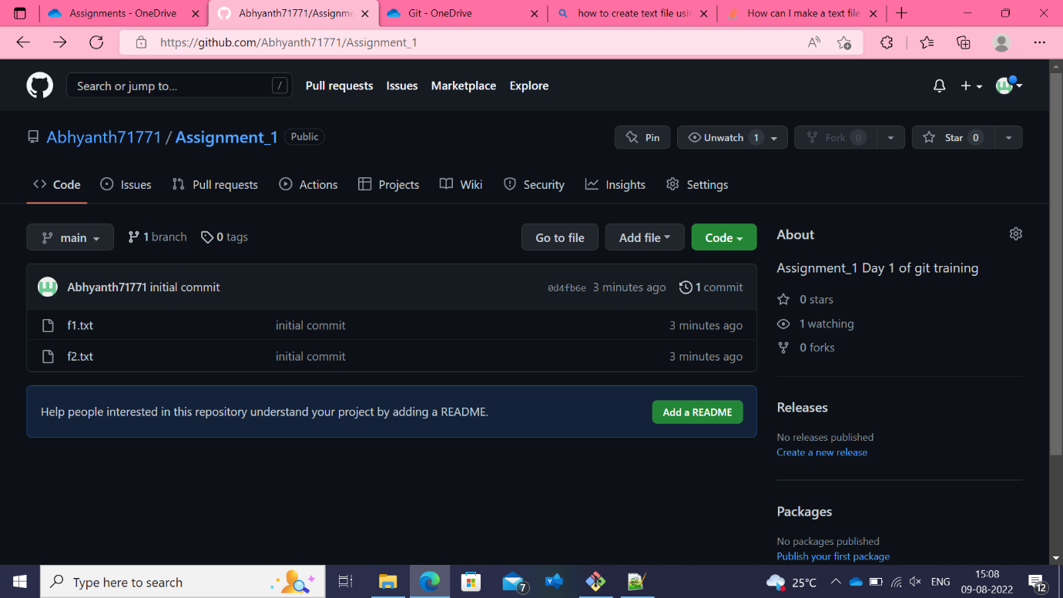

8. 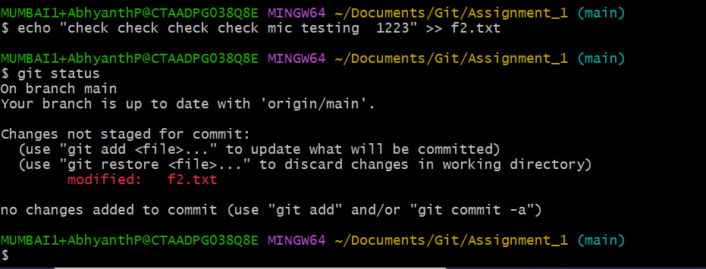

9. 

10.

We don’t see any contents added to f2.txt in the remote repo as we have not yet pushed the modified the f2.txt file into the remote repo

11. 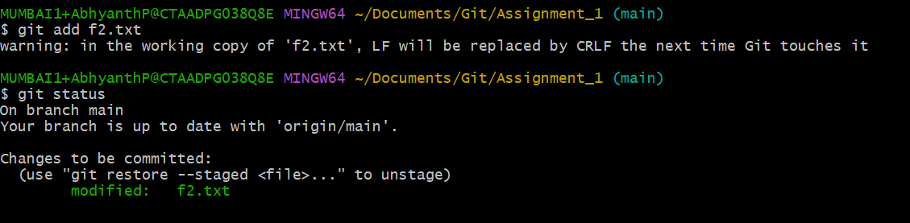

12. We don’t see any contents added to f2.txt in the remote repo as we have not yet pushed the modified the f2.txt file into the remote repo

13.

